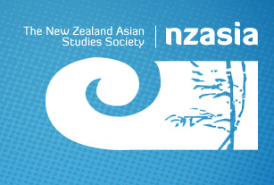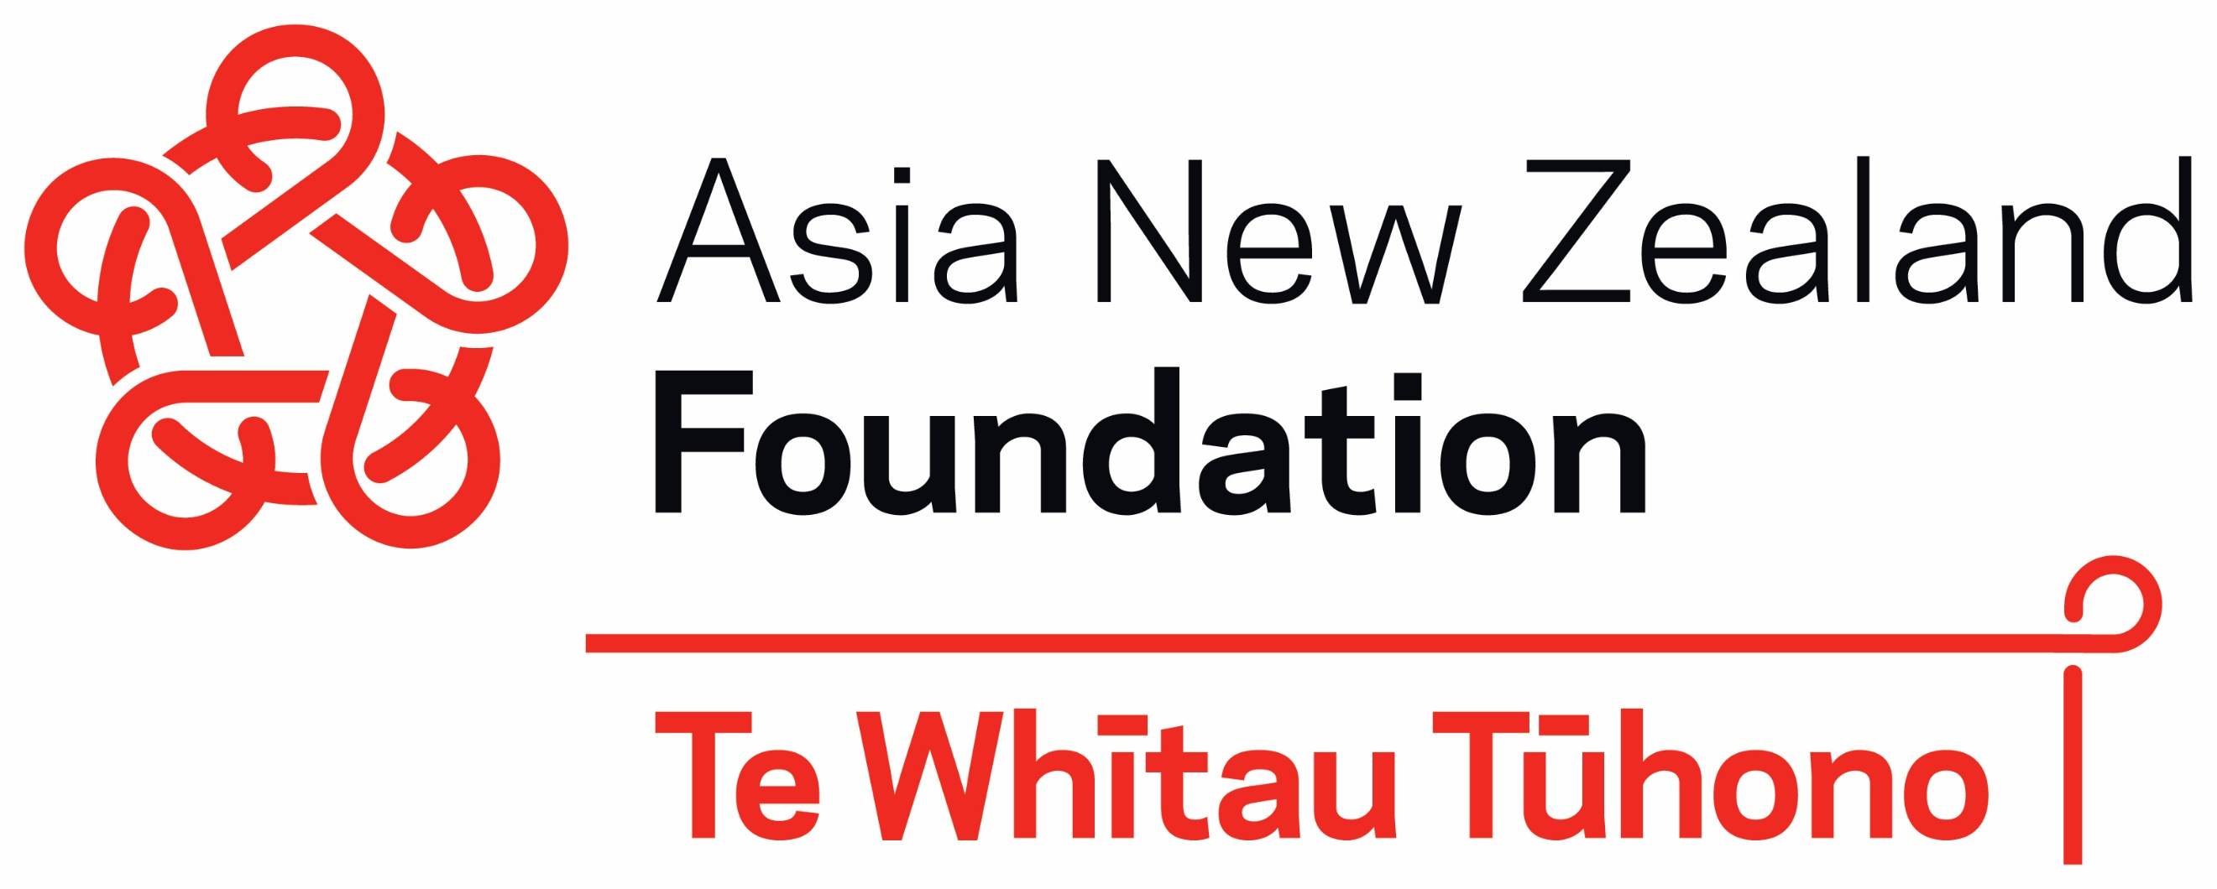

NZASIA Pre-Conference Asian Studies Postgraduate Workshop

at Massey University, Palmerston North
Wednesday 24th November 2021, 12pm to 4pm

In conjunction with the 24th NZASIA Conference, the Asia New Zealand Foundation will offer postgraduate students who are working on Asia-related topics the opportunity to participate in a pre-conference postgraduate workshop.

This workshop will provide a forum for students from different universities to meet each other and share their interests on Asia-related subjects. The workshop will also be an opportunity for postgraduates to explore career pathways both in academia and the public/trade/foreign policy sector. The workshop is free and open only to postgraduate students who have registered and paid for the main conference.

Provisional Schedule:

12.00pm: Welcome/Networking Lunch

12.45pm: Postgraduate Workshop – tips and advice for postgraduate life; highlighting Asia-related careers/academic pathways; making the most of your thesis for publication and profile

2.00pm: Coffee break

2.15pm: NextGen Workshop - getting the most out of Track II diplomacy/Conference participation

2.30pm: Track II Vocabulary and Terms – the Asia-related issues you need to know about~

3.00pm: NextGen Track II Roundtable – Experiencing Track II diplomacy with a deep dive conversation on topical issues across Asia

Please register for the Postgraduate Workshop when you sign up and pay for attendance at the NZASIA Conference. For any enquiries, please contact Dr James To, Senior Adviser (Research and Engagement) jto@asianz.org.nz

